Date 28/2/2025

EXPERIMENT-12
CONFIGURATION OF A SIMPLE DYNAMIC ROUTING IN PACKET TRACER USING A SIMPLE TOPOLOGY WITH TWO ROUTERS

Aim: To Configure a router using packet tracer software and hence to transmit data between the devices in real time mode and simulation mode.
Software/Apparatus required: Packet Tracer/End devices, Hubs, connectors.
Procedure:
Steps for building topology:
Step 1: Start Packet Tracer
Step 2: Choosing Devices and Connections Step 3: Single click on the End Devices.
Single click on the Generic Host.
Place PC0, PC1 on topology area.
Connect PCs to Switch 1.
Similarly Place PC2, PC3 on topology area for receiver side
Connect these PCs with switch 1 and 2 respectively through connecting wires.
Select Router and place the router between two switches.
Connect these switches into router through connecting wires.
Step 3: Configuring IP Addresses, Gate Way and Subnet Masks on the Hosts
To start communication between the hosts IP Addresses, subnet Masks and Gate way had to be configured on the devices. Click once on PCs. Choose the Config tab and click on FastEthernet0. Type the IP address in its field. Based on router create gate way click on the subnet mask. It will be generated automatically. Step 4: Verifying Connectivity in Real time Mode Be sure you are in Real time mode.
Select the Add Simple PDU tool used to ping devices.
Click once on PC0, then once on PC3.
The PDU Last Status should show as Successful.
Step 5: Verifying Connectivity in Simulation Mode Be sure you are in Simulation mode.

Deselect all filters (All/None) and select only ICMP. Select the Add Simple PDU tool used to ping devices Click once on PC0, then once on PC3.
Continue clicking Capture/Forward button until the ICMP ping is completed. The ICMP messages move between the hosts, hub and switch. The PDU Last Status should show as Successful.

Diagram:
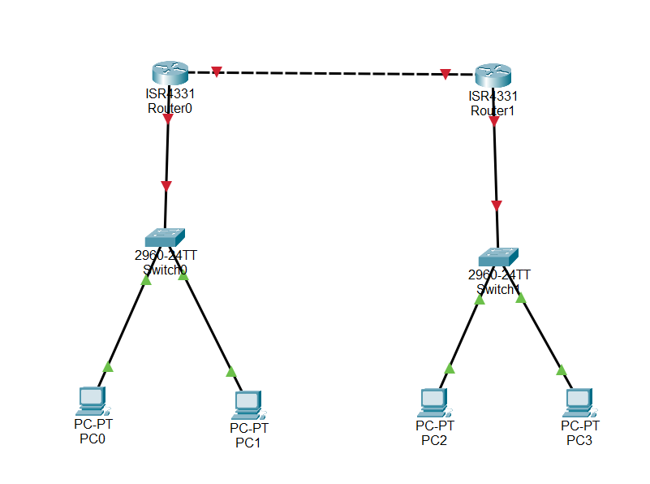

Output:
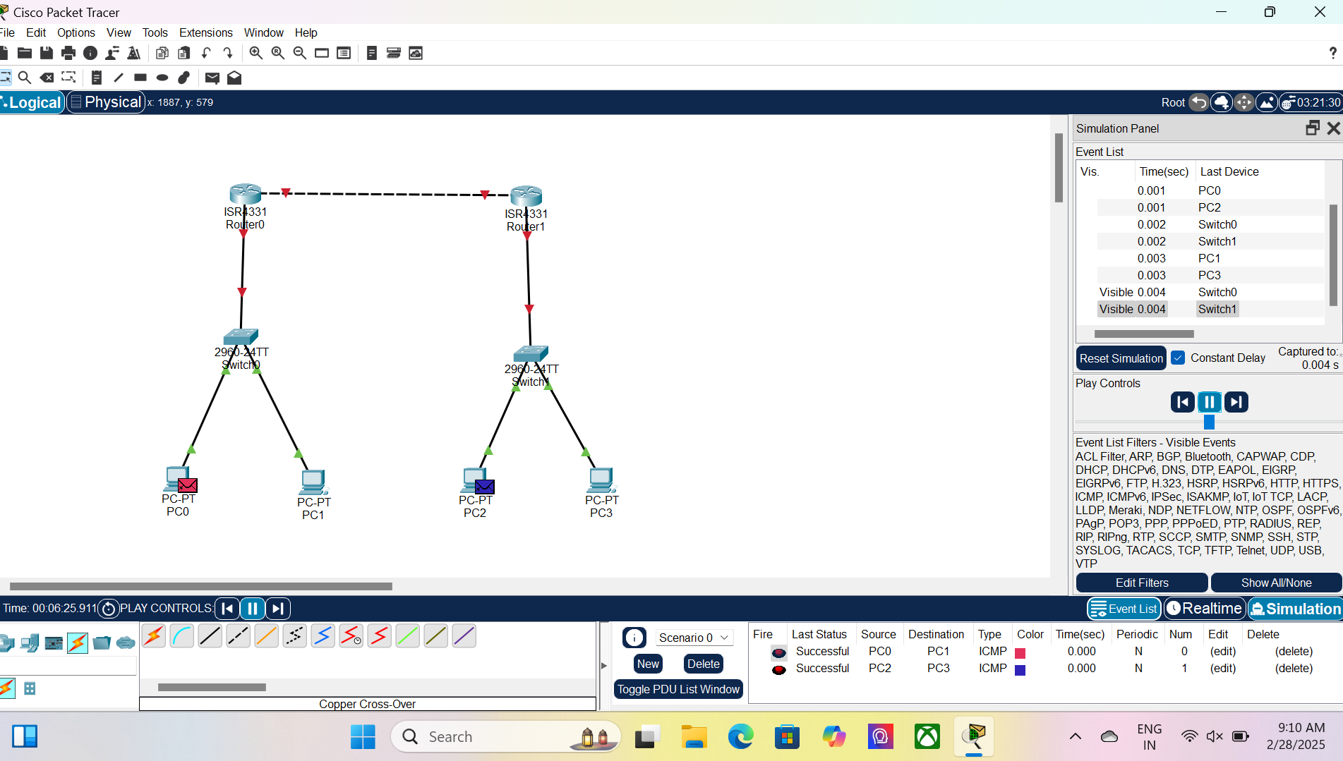

Result: Thus Configuration of a simple dynamic routing in packet tracer using a simple topology with two routers was done successfully.

